Purpose: This simple project charter form provides the framework for defining the key aspects of your project and ensuring that all stakeholders are aligned on the objectives, scope, and deliverables.

|  |  |
| --- | --- |
| **Project Charter** | |
| **Project Name** | **Project Sponsor** |
| **Date:** Click or tap to enter a date. | **Project Managers** |
| **Project Summary:**  Briefly state the overall goal of the project. | |
| **Project Scope:**  Likst the key activities included in the project. | |
| **Deliverables:**  List the key outputs for the project | |
| **Internal Stakeholders:**  Key internal departments or individuals involved in the project | |
| **External Stakeholders:**  List key external parties involved | |
| **Project Success Criteria**  *Completion of the project within budget and on schedule, Positive feedback from pilot participants, Increased customer satisfaction scores, Reduced service call volume.* | |
| **Project Timeline**  Start Date: Click or tap to enter a date.  End Date:Click or tap to enter a date. | **Project Budget**  Total Project Budget:  Funding Source: |
| **Project Sponsor Approval**  **Date** Click or tap to enter a date. | **Project Manager Approval**  **Date** Click or tap to enter a date. |

**Project Baseline & Fact Gathering**

Purpose: this form should be completed collaboratively with key stakeholders to ensure everyone is aligned to the project objectives and scope. The information gathered int his will be used to create a project baseline, which will serve as a reference point for tracking progress and adjusting as needed

|  |  |  |
| --- | --- | --- |
| **#** | **TOPIC** | **Contents** |
| **1** | **Project Objectives** | * **What are the primary goals of this project?** * **What specific business problems or opportunities are you trying to address?** * **What are the desired outcomes of the project?** *(increased revenue, improved customer satisfaction, reduced costs)* |
| **2** | **Project Scope** | **Inclusions:**   * What specific activities, deliverables, and tasks are included within the scope of this project? * What are the key features or functionalities of the project?   **Exclusions:**   * What activities, deliverables, and tasks are not included within the scope of this project? * What are the limitations or constraints of the project? |
| **3** | **Project Assumptions** | **What assumptions are being made about the project?**   * *"Availability of resources," "Market conditions will remain stable," "Technology will function as expected."* |
| **4** | **Project Constraints** | * **What are the key constraints that may impact the project?** * *Budget limitations, Time constraints, Resource limitations, Regulatory requirements, Technical limitations.* |
| **5** | **Project Risks** | * **What are the potential risks that could impact the project?** * *Technical challenges, Budget overruns, Schedule delays, Resource shortages, Changes in business requirements.* |
| **6** | **Stakeholders** | **Internal Stakeholders:**   * Who are the key internal stakeholders involved in this project? * What are their roles and responsibilities?   **External Stakeholders:**   * Who are the key external stakeholders involved in this project? * What are their roles and responsibilities? |
| **7** | **Project Resources** | * **What resources are required for this project?** * *Human resources (skills, experience), Equipment, Software, Budget, Materials.* |
| **8** | **Communication Plan** | * **How will information be communicated within the project team?** * **How will stakeholders be kept informed of project progress?** * **What communication tools will be used?** *(meetings, email, project management software)* |
| **9** | **Decision Making Process** | * **How will key project decisions be made?** * *Consensus, Voting, Approval by project sponsor.* |
| **10** | **Project Artifacts & Documentation** | * **What project documentation will be maintained throughout the project lifecycle?** * *(Project charter, Risk register, Issue log, Change requests, Status reports.* |

**SWOT Analysis**

**Strengths, Weaknesses, Opportunities, Threats**

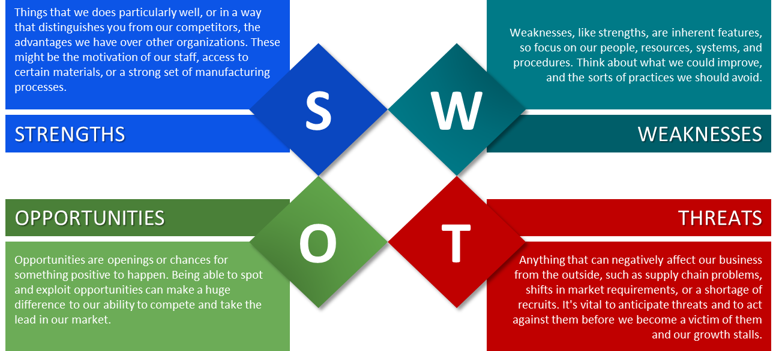

|  |  |
| --- | --- |
| **Strengths (S)**   1. Team Commitment 2. Experienced and Knowledge Experts 3. Clear Scope, Objectives, Roadmap 4. Regulatory Compliance Understanding 5. Project Management Professionals (PMP) and compliance automatically built into this work | **Weaknesses (W)**   1. Employee Resistance to Changes 2. Resource Constraints and Bottlenecks 3. Lack of Motivation without Training 4. Incomplete Documentation/ Unknown process 5. Project Deadlines 6. Lack of Risk Mitigation Understanding |
| **Opportunities (O)**   1. Improved Daily Efficiency & Consistency 2. Cost Reduction and Greater Decision-Making 3. Greater Employee Onboarding process 4. Enhanced Quality in Services/ Products 5. Responsibilities Defined & Accountability 6. Employee Empowerment/ Confidence 7. Market Advantage 8. Risk Reduction | **Threats (T)**   1. Employee Fatigue feeling information overload 2. Competitive Pressure 3. Regulatory Changes 4. Resource Limitations/ Lack of Prioritization 5. Technology Issues 6. Lack of Employee Understanding during initial project rollout (heavy training required) 7. Employee Turnover/ Lack of Knowledge Transfer 8. Lack of commitment of managers to enforce compliance and usage |